**Geographic Inequalities and Determinants of Aneamia among Preeclamptic Women in Bangladesh**

**Author’s name:**

Md. Ahasan Ali1*, Jahirul Islam2, Dr Ratna Paul3, Shahinur Parvin4, Abu Taiub Mohammed Mohiuddin Chowdhury5, Rafiqul Islam6, Dr Sharmina Siddique7, Md Atiqur Rahman8, Sayeda Tamanna Tasnim9, Suraiya Hasna10

* Correspondence: [mr_ahsanhabib@yahoo.com](mailto:mr_ahsanhabib@yahoo.com)

1Dept. of Pathology and Pathophysiology, Xi’an Jiaotong University, Shaanxi, China.

**ABSTRACT**

**Background:** Anaemia is among preeclamptic women's main health problems in Bangladesh. Aneamia affects pregnant women and women of reproductive age who have hemoglobin levels below 11.0 g/dl. In Bangladesh, the prevalence of aneamia among pregnant women is 42.2%, compared to a global incidence of 38.2%, which raises a major public health concern.

**Methods:** Information from 180 respondents was gathered from the Department of Gynecology and Obstetrics, Preeclampsia (PE) ward at Dhaka Medical College Hospital (DMCH), Dhaka, Bangladesh, between September 2021 and August 2022 [Ethical approval Ref: Memo No. ERC-DMC/ECC/2022/31]. Factors associated with aneamia were explored using the chi-square test, and then we performed multinomial logistic regression (MLR) to determine the level of association with the risk factors. We further conducted cluster analysis, Global *Moran’s I*, and Anselin local *Moran’s I* to check the geographical distribution of anaemia cases from our sample.

**Results:** Early and late PE onset were recorded and classified into two categories; 28.9% of respondents reported an early onset of PE, while 71.1% reported a late onset of PE. A total of 38.9% of subjects had normal hemoglobin counts, whereas 38.3% had mild aneamia. A total of 17.8% had moderate aneamia, and 5.0% had severe aneamia. By performing MLR, anaemia had a statistically significant association with several underlying factors, e.g., recreational substance use (RR= 83.093, 95% CI- 3.351 to 2060.315), gestational age (RR= 10.235, 95% CI- 1.478 to 70.879), gestational diabetes mellitus (RR= 4.906, 95% CI- 1.920 to 12.532), pregnancy interval (RR= 4.374, 95% CI- 1.338 to 4.303), education (RR=3.448, 95% CI- 1.542 to 7.709), profession (RR= 0.263, 95% CI- 0.109 to 0.635), parity (RR= 0.117, 95% CI- 0.026 to 0.529), and respondent age (RR=0.160, 95% CI- 0.032 to 0.802). Higher incidence rates for all kinds of aneamia were observed in the Dhaka, Narayanganj, and Munshiganj districts. The global *Moran’s I* value ranged from 0.14 to 0.44, and high-high cluster regions were detected in the central region.

**Conclusions:** The risk factors indicated in this study and geographical inequalities will help policymakers take necessary steps. The geographical distribution of the incidence rate raises concern for further research, including sociodemographic and environmental factors. This will assist in determining the determinants of aneamia and suggest possible measures.

**Keywords:** Preeclampsia, aneamia, Bangladesh, MLR, Spatial

Background

Aneamia is an important public health burden worldwide, especially for women of reproductive age and pregnant women. Aneamia prevalence in pregnant women is 42.2% in Bangladesh, compared to a global prevalence of 40% (1, 2). The World Health Organization (WHO) defined aneamia as a hemoglobin level ˂ 11.0 g/dl for pregnant women and ˂ 12.0 g/dl for women who are not pregnant (3). Aneamia inhibits oxygen transportation into the blood, resulting in negative effects and outcomes (low birth weight, preterm delivery, stillbirth, and fetal aneamia) for the mother and fetus (4-6). Anaemia is a serious public health issue, with detrimental effects on a woman's health (7), with particular impacts on mothers and children under the age of five (8). These impacts include significant maternal morbidity and mortality (9), anxiety (10, 11), high blood pressure levels (12, 13), and detrimental consequences on the baby, such as birth defects and premature delivery, which can all be caused by aneamia. Aneamia caused adverse effects in 38% of pregnant women and 29% of nonpregnant women worldwide in 2011 (8) and affects pregnant women at high rates in low- and middle-income (LMIC) nations.

Aneamia, eclampsia, and preeclampsia are prevalent conditions in underdeveloped nations. According to the WHO, a 5–19% prevalence indicates mild public health concern, whereas Sub-Saharan Africa, India, Bangladesh, and Iran report that more than 40% of pregnant women suffer from this (14). Women in impoverished countries frequently suffer preeclampsia and eclampsia, although the number of cases is beyond the range of 15-20% in high-income nations similar to the USA (15). Given preexisting obstacles such as gender disparities, a paucity of healthcare and family planning, and deprivations, other women in low-income countries are at the greatest risk of aneamia. Due to inadequate acclimation to seasonal shifts, vulnerability will consequently amplify the influence of seasonal fluctuations on maternal outcomes (16). Preeclampsia is primarily influenced by the weight, age, personal and family ancestry of high blood pressure, and diabetes in the mother (17, 18). Increased occurrence in Latin American countries has been linked to variables including social economic position, national development, and advancements in diagnosis (19, 20). Crucial risk factors for elevated morbidity and death in preeclamptic mothers include late care-seeking behavior, delayed diagnosis, and delayed management (21). According to a recent study, the risk of eclampsia is 50% higher for nulliparous women who live more than one hour away from obstetric facilities (21). Previous studies have also suggested that preeclampsia is influenced by high altitude during pregnancy (22-24). Therefore, the principal goal of this study is to determine the risk factors associated with preeclampsia and demonstrate the regional variation in Bangladesh.

**Methods**

*Study setting and design*

The Department of Gynecology and Obstetrics at the Dhaka Medical College Hospital (DMCH) in Dhaka, Bangladesh, launched a hospital-based cross-sectional study from September 2021 to August 2022. A total of 180 of the 210 preeclamptic pregnant mothers who were recruited for the study and regularly assessed at these clinics gave their permission. The patient's anthropometric measurements (height, weight), sociodemographic, personal, and family histories of diabetes and hypertension, and lifestyle preferences (working or sedentary) were all recorded on a questionnaire form. Information about preexisting hypertension and the need for antihypertensive medications was acquired based on individual reports or medical records. Systolic blood pressure (SBP) and diastolic blood pressure (DBP) were measured at DMCH using mercury sphygmomanometer equipment after the patient had rested for at least 10 minutes. The participant's blood pressure was checked from the right side, and they were weighed using a weighing scale (Beurer BF 700, Germany), both without shoes and without bulky clothing. The nearest 0.1 kilogram (kg) was used to measure weight.

*Inclusion criteria*

Pregnant women with preeclampsia in the second trimester were recruited for this study. Defined as women with previously normal blood pressure (BP), after the 20th week of gestation with two different measures of BP that were at least four hours apart, diastolic ≥ 90 mmHg and systolic ≥ 140 mmHg with a dipstick value of 1+ proteinuria of 300 mg or more per 24-hour urine sample (25).

*Exclusion criteria*

Participants who already had renal disease, had a family history of diabetes mellitus, thyroid problems, or liver disease, or had a history of PE were excluded from the study. We took into consideration the subjects' self-reported information and/or medical history of their prior conditions when we removed the participants.

*Data collection tools and procedure*

Face-to-face interviews were performed to assemble data using a previously tested (Ad-din Women Medica College Hospital Dhaka, Bangladesh) semi structured questionnaire. The questionnaire was written in English and translated to Bengali. Two BSc nurses were engaged to accumulate data and trained before data collection. The principal investigator coordinated data collection and checked the inclusiveness of the collected questionnaire. The medical record was reviewed for clinical investigation and another laboratory report.

*Statistical analysis*

After compiling the data from our study sample, all information was imported into Excel 2016 by Microsoft, USA. The baseline data variables were presented using descriptive statistics. *P values* for comparing quantitative variables were determined using the chi-square test. Using multinomial logistic regression (MLR), the association level with the risk factors was investigated. The independent variables that were important in the univariate analysis as well as some relevant variables were counted in the MLR models with a p value < 0.05 as significant. We determined the normal aneamia. We collected the female population district wise to determine the incidence rate for normal (>10.91 g/dl), mild (10.0-10.9 g/dl), moderate (7.0-9.9 g/dl), and severe (<7.0 g/dl) aneamia.

$$Incidence rate \left(IR\right)=\frac{Case (district-wise)}{Female population }×100,000$$

The spatial variation was determined using cluster analysis using the global *Moran’s I* and Anselin Local *Moran’s I* test. Spatial heterogeneity was conducted by the district wise IR, and then we performed Pearson correlation to check regional relationships for mild, moderate, and severe types of aneamia. All analyses were performed using the IBM SPSS 25.0 statistical software program and ArcGIS pro (version 3.1.2).

**Results**

## *Sociodemographic characteristics*

A total of 180 respondents participated in this survey. Approximately 36.7% (66) were aged 15 to 24 years, more than half (55.0%) were between the ages of 25 and 34 years (99), and only 8.3% (15) were more than 35 years old. The mean age was 26.85 ± 5.3. The education level of the mother was 62.2% below secondary school certificate (SSC), and 37.8% was higher secondary school certificate (HSC) or above school certificate. The majority of the participants were housewives, with only 29.4% as the service holder. According to family income, 70% of respondents belonged to the lower mid-income category, 9.4% belonged to the low-income category, and only 1.1% belonged to the high-income category. Based on physical activity, more than 50% of study participants reported a sedentary lifestyle. A total of 27.8% of respondents had more than five family members, compared to 72.2% of respondents who had 1-4 family members. Regarding the use of recreational substances, 63.3% of the respondents reported not using any recreational substances, while 14.4% reported using betel nuts. Of the respondents, 15.6% reported using nuts, and 4.4% reported using tobacco leaves. Only 2.2% of the respondents reported using cigarettes.The dependent and independent variables' sociodemographic characteristics are shown in Table 1 along with their frequency and proportion.

|  |  |  |
| --- | --- | --- |
| **Characteristics** | **Frequency** | **Percentage (%)** |
| **Age** | | |
| 15-24 | 66 | 36.7 |
| 25-34 | 99 | 55.0 |
| >35 | 15 | 8.3 |
| Mean ± SD | 26.85 ± 5.3 | |
| **Living area** | | |
| Urban | 67 | 37.2 |
| Rural | 113 | 62.8 |
| **Mother education** | | |
| <SSC | 112 | 62.2 |
| HSC or above | 68 | 37.8 |
| **Mother profession** | | |
| Service | 53 | 29.4 |
| Housewife | 127 | 70.6 |
| **Family income** | | |
| low income (<5360) | 17 | 9.4 |
| lower mid-income (5361-21270) | 126 | 70.0 |
| upper mid-income (21271-65761) | 35 | 19.4 |
| High income (>65762) | 02 | 1.1 |
| **Physical activity of the patient** | | |
| Exercise | 85 | 47.2 |
| No exercise | 95 | 52.8 |
| **Family member** | | |
| 1-4 | 130 | 72.2 |
| >5 | 50 | 27.8 |
| **Use of the recreational substance** | | |
| No | 114 | 63.3 |
| Betel nut | 26 | 14.4 |
| Nut | 28 | 15.6 |
| Tobacco leaf | 08 | 4.4 |
| Cigarette | 04 | 2.2 |

**Table 1** Sociodemographic features of the respondents, n = 180

Diastolic blood pressure (DBP) was 75.89 ± 5.7 mmHg, and the average systolic blood pressure (SBP) was 150.5 ± 12.4 mmHg. In the parity of cases, 60.6% were 1-4 parity, 28.3% were prime gravida, and 10.5% were parity of >5. The most common contraceptive method used was the natural barrier, with 33.3% of the respondents using this method. A total of 37.2% of the respondents used condoms, while 15% used oral contraceptive pills and 5% used contraceptive implants. Eighty-two percent of respondents (82.2%) had a pregnancy break of less than 24 months, while 17.8 percent had a break of more than 24.1 months. The obstetrical and anemic characteristics of 180 respondents are illustrated in Table 2.

**Table 2** Obstetrical and anemic personality traits of the respondents, n = 180

|  |  |  |
| --- | --- | --- |
| **Characteristics** | **Frequency** | **Percentage (%)** |
| **Blood pressure** | | |
| SBP (mmHg) | 150.47 ± 12.4 | |
| DBP (mmHg) | 75.89 ± 5.7 | |
| **Parity of case** | | |
| primi gravida | 51 | 28.3 |
| 1-4 | 109 | 60.6 |
| >5 | 20 | 11.1 |
| **Contraceptive method** | | |
| Condom | 67 | 37.2 |
| Natural barrier | 60 | 33.3 |
| OCP | 04 | 2.2 |
| Injection | 08 | 4.4 |
| Pill | 27 | 15.0 |
| Implant | 09 | 5.0 |
| Copper-T | 05 | 2.8 |
| **Interval in pregnancy** | | |
| <24 month | 148 | 82.2 |
| >24.1 months | 32 | 17.8 |
| **BMI in pregnancy** | | |
| Normal BMI | 109 | 60.4 |
| Overweight | 44 | 25.4 |
| Obese | 04 | 2.2 |
| Underweight | 23 | 12.8 |
| **Gestational diabetics mellitus** | | |
| Yes | 52 | 28.9 |
| No | 128 | 71.1 |
| **Gestational age** | | |
| <34 weeks | 42 | 23.3 |
| 34-37 weeks | 76 | 42.2 |
| >37 weeks | 62 | 34.4 |
| **Onset of PE** | | |
| Early onset of PE | 52 | 28.9 |
| Late onset of PE | 128 | 71.1 |
| **Aneamia level in PE patient** | | |
| Normal | 70 | 38.9 |
| Mild aneamia | 69 | 38.3 |
| Moderate aneamia | 32 | 17.8 |
| Severe aneamia | 09 | 5.0 |

Note: SBP-systolic blood pressure, DBP-diastolic blood pressure, OCP- oral contraceptive pill.

Based on recorded weight and height, 60.4% of the respondents had a normal body mass index (BMI) in pregnancy, while 25.4% were classified as overweight. A total of 12.8% were underweight, and 2.2% were obese. Gestational diabetes mellitus status was recorded, with 71.1% of the respondents reporting no gestational diabetes, while 28.9% reported having gestational diabetes. Regarding the gestational age of the respondents, 42.2% of the respondents were at a gestational age of 34-37 weeks, while 23.3% were less than 34 weeks and 34.4% were more than 37 weeks.

By performing MLR, we exposed the association of aneamia with several determinants. Before that, we conducted a chi-square test to obtain the significant indicators. The results showed a positive association of aneamia less than 10.90 with secondary (SSC) level education (RR=3.448, 95% CI- 1.542 to 7.709), mother professionals who are involved in the service sector (RR= 0.263, 95% CI- 0.109 to 0.635), recorded parity of case from 1-4 (RR= 0.117, 95% CI- 0.026 to 0.529), pregnancy interval of fewer than 24 months (RR= 4.374, 95% CI- 1.338 to 4.303), recreational substance (tobacco leaf) user (RR= 83.093, 95% CI- 3.351 to 2060.315), those who had gestational diabetes mellitus (RR= 4.906, 95% CI- 1.920 to 12.532), and gestational age under 34 weeks (RR= 10.235, 95% CI- 1.478 to 70.879). Table 3 illustrates the MLR findings.

**Table 3** Association between predictor determinants and aneamia (Hb- <10.9 g/dl)

|  |  |  |  |
| --- | --- | --- | --- |
| **Characteristics** | **Risk Ratio** | **95% CI** | ***P value*** |
| **Recorded age** | | | |
| 15-24 | 0.433 | 0.080-2.341 |  |
| 25-34 | 0.160 | 0.032-0.802 | <0.05 |
| >35 | 1 | 1 |  |
| **Mother education** | | | |
| <SSC | 3.448 | 1.542-7.709 | <0.01 |
| HSC or above | 1 | 1 |  |
| **Family Income** | | | |
| Low income | 2.265 | 0.110-46.490 | >0.05 |
| Lower mid Income | 0.471 | 0.030-7.468 |
| Upper mid-income | 0.347 | 0.021-5.642 |
| High income | 1 | 1 |
| **Mother profession** | | | |
| Service | 0.263 | 0.109-0.635 | <0.01 |
| Housewife | 1 | 1 |  |
| **Parity of case** | | | |
| Primi gravida | 0.253 | 0.046-1.400 |  |
| 1-4 | 0.117 | 0.026-0.529 | <0.05 |
| >5 | 1 | 1 |  |
| **Family member** | | | |
| 1-4 | 0.614 | 0.238-1.583 | >0.05 |
| >5 | 1 | 1 |  |
| **Contraceptive method** | | | |
| Condom | 0.184 | 0.014-2.446 | >0.05 |
| Natural barrier | 0.136 | 0.011-1.693 |
| OCP | 0.221 | 0.007-7.326 |
| Injection | 2.556 | 0.106-61.726 |
| Pill | 0.171 | 0.011-2.666 |
| Implant | 1.118 | 0.046-27.561 |
| Copper-T | 1 | 1 |
| **Interval in pregnancy** | | | |
| <24 months | 4.374 | 1.338-4.303 | <0.05 |
| >24.1 months | 1 | 1 |  |
| **BMI in pregnancy** | | | |
| Normal BMI | 1.040 | 0.332-3.256 | >0.05 |
| Overweight | 0.571 | 0.140-2.323 |
| Obese | 0.346 | 0.055-2.172 |
| Underweight | 1 | 1 |

**Table 3** *(Continued)*

|  |  |  |  |
| --- | --- | --- | --- |
| **Characteristics** | **Risk Ratio** | **95% CI** | ***P value*** |
| **Recreational substance** | | | |
| No | 6.266 | 0.547-71.794 | >0.05 |
| Betel nut | 8.888 | 0.673-117.382 |  |
| Nut | 4.507 | 0.353-57.501 |  |
| Tobacco leaf | 83.093 | 3.351-2060.315 | <0.01 |
| Cigarette | 1 | 1 |  |
| **Gestational diabetics mellitus** |  |  |  |
| Yes | 4.906 | 1.920-12.532 | <0.01 |
| No | 1 | 1 |  |
| **Gestational age** |  |  |  |
| <34 wks. | 10.235 | 1.478-70.879 | <0.05 |
| 34-37 wks. | 1.414 | 0.620-3.225 | >0.05 |
| >37 wks. | 1 | 1 |  |
| **Onset PE** |  |  |  |
| Early <34 wks. | 0.414 | 0.084-2.030 | >0.05 |
| Late >34 wks. | 1 | 1 |  |

The onset of PE was recorded and divided into two categories: early onset of PE and late onset of PE. A total of 28.9% of respondents reported an early onset of PE, while 71.1% reported a late onset of PE. Overall, 38.9% of participants had normal levels of hemoglobin, whereas 38.3% had mild aneamia. A total of 5.0% had severe aneamia, and 17.8% had moderate aneamia, as demonstrated in Fig 1.

**Fig 1** Prevalence of aneamia and outcome of PE among the respondents

*Geographical heterogeneity of the IR and cluster analysis*

After calculating the incidence rate, we found higher incidence rates in the Dhaka (IR: 0.09-0.54), Narayanganj (IR: 0.05-0.48), Munshiganj (IR: 0.12-0.36) and Narsinghdi (IR: 0.00-0.15) districts for normal aneamia, as depicted in Fig 2 (A). We further detected the geographical distribution of mild aneamia, moderate aneamia and severe aneamia, as illustrated in Fig 2, Map (B), Map (C), and Map (D), respectively. The correlation among the districts for the incidence rate of normal, mild, moderate, and severe aneamia was stronger (r > 0.68, *p value* < 0.01), which indicates that there was homogeneity among the locations. The global *Moran’s I* was used to measure the clusters for mild, moderate, and severe aneamia. We illustrated the *Moran’s I* result in Fig 3, and we found that the *Moran’s I* value ranged from 0.14-0.44. Therefore, using Anselin Local *Moran’s I*, we found several clusters of mild, moderate, and severe types of aneamia among our respondents. Most of the cluster districts are in the central region. Although our sample size was limited, we identified significant clusters for the moderate and mild types of aneamia.

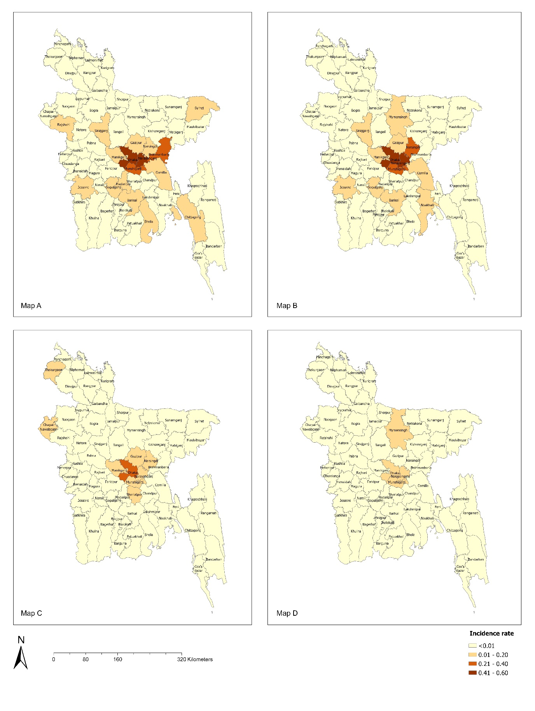**Fig 2** Geographical distribution of the anaemia incidence rate (IR) in Bangladesh using the sample data. Map (A) IR for normal aneamia (> 10.91 g/dl), Map (B) IR for mild aneamia (10.0 – 10.9 g/dl), (C) IR for moderate aneamia (7.0 – 9.9 g/dl), (D) IR for severe aneamia (< 7.0 g/dl).

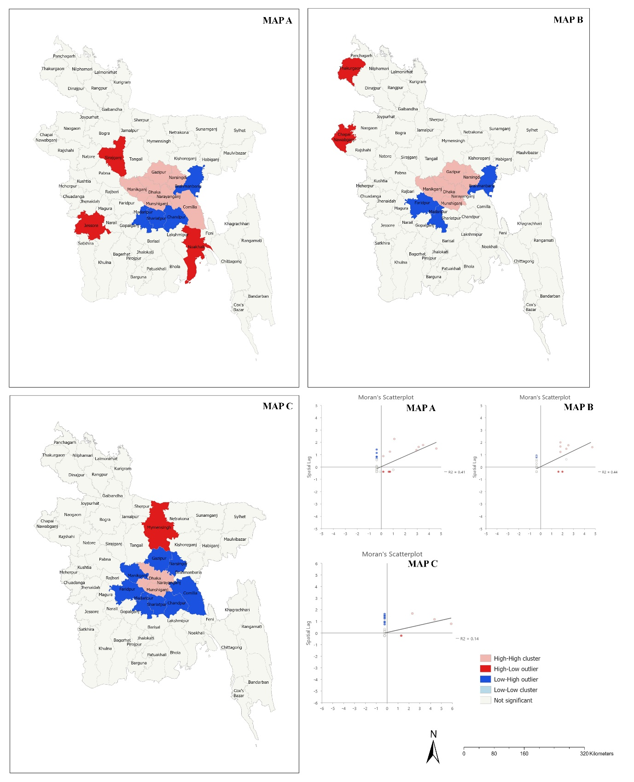

**Fig 3** Geographical cluster of aneamia incidence rate (IR). Map (A) cluster map for normal aneamia (> 10.91 g/dl), Map (B) cluster map for mild aneamia (10.0 – 10.9 g/dl), (C) cluster map for moderate aneamia (7.0 – 9.9 g/dl), (D) cluster map for severe aneamia (< 7.0 g/dl).

**Discussion**

Aneamia is one of the major public health issues affecting preeclamptic women in Bangladesh. It can be influenced by the absence of healthcare facilities and dietary supplements (maternal care, adequate nutrition education). Our findings are higher than the global average of approximately 40% of pregnant women with aneamia. However, this number may be attributed to one institutional base study or this population. Generally, aneamia is affected by many circumstances, such as a lack of medical services and dietary supplements. The WHO states that if aneamia prevalence is ≥ 40% in any population, a serious population health issue exists (26, 27). In this study, approximately 20.5% of PE mothers experienced preterm birth whose hemoglobin levels (Hb) were less than 10.9 g/dl. Another study with similar results found that PE was related to low (Hb) levels throughout the early part of pregnancy (28). In addition, preeclampsia and low maternal Hb levels were discussed as indicators of poor socioeconomic and nutritional conditions in developing countries (29). The opposite view is that a high hemoglobin concentration is related to PE; in primiparas, 7% of hypertension is documented with Hb < 10.5 g/dl and 42% with Hb > 14.5 g/dl (30). A geographic study conducted in Nepal showed a non-random spatial distribution, with statistically significant hotspots and cold spots indicating the spatial and temporal significance of aneamia (31). Our findings revealed additional factors that were associated with aneamia, including the age of the mothers, educational qualifications, career, parity number, use of recreational drugs, gestational age, and gestational diabetes mellitus.

To our knowledge, this is the first study to investigate the factors that contribute to aneamia in preeclamptic pregnancy in Bangladesh. We highlight the case distribution of aneamia where effective public health measures should be taken to reduce the risk. Furthermore, by conducting spatial analysis, the cluster areas were detected. Our research opens several prospective opportunities. The sociodemographic and economic data districtwise have yet to be explored. The districtwise aggregated number of cases, individual patient information, healthcare data, etc., should be used in future research. We found that aneamia leading to preeclampsia is related to several environmental factors, e.g., household environment (32), household size, passive smoking (33), ambient air pollution (34, 35), walkability (36, 37), etc. Therefore, future studies can address those factors in determining the overall risk. The weakness of this study should also be mentioned. First, we used a limited number of samples; therefore, the causal relationship withdrawn from this study questions the reliability. Furthermore, we have assumed that the patients of the total sample represent the total geographical distribution of the country without addressing more data from state wise or division wise. Although we did not gather data from each district or division, our results demonstrate some validity in considering the determinants of aneamia. It is obvious that with more epidemiological data, robust analysis is possible, which is possibly our future direction.

**Conclusion**

By exploring the related risk factors and adjusting the indicators in the model, we found that various biomarkers contributed to aneamia prevalence in the Bangladesh population. These findings can support the implementation of aneamia-related programs and inform public health policies to address aneamia problems. Our study demonstrated preliminary factors associated with aneamia and geographical inequalities. We further showed evidence about the aneamia clusters in Bangladesh within our sample that can assist in formulating more research questions to be explored in the future.

**List of abbreviations**

g/dl: grams per deciliter; PE: preeclampsia; DMCH: Dhaka Medical College Hospital; MLR: multinomial logistic regression; WHO: World Health Organization; SBP: systolic blood pressure; DBP: diastolic blood pressure; BP: blood pressure; BSc: Bachelor of Science; IRB: Institutional Review Board (BRB); SSC: secondary school certificate; HSC: higher secondary school certificate; BMI: body mass index; Hb: hemoglobin; IRB: Institutional Review Board; LMIC: low and middle income.

**Declarations**

**Ethics approval and consent to participate**

The research was authorized by the Institutional Review Board (IRB) of Dhaka Medical College (DMC), Dhaka, Bangladesh [Ref: Memo No. ERC-DMC/ECC/2022/31]. Before being enrolled in the study, all participants were acknowledged of its objectives and allowed to provide written inform consent and sign inform consent collected from legal guardian. The decision to participate was entirely optional. Throughout the study duration, confidentiality was rigorously maintained. The current study's methodologies were all performed under the necessary standards and laws. We had 3 respondents aged below 18, we have attached their consent form from their legal guardian in the Supplementary Material.

**Consent for publication**

Not applicable.

**Availability of data and materials**

The datasets used and/or analysed during the current study are available from the corresponding author upon reasonable request.

**Competing interests**

The authors declare that they have no competing interests.

**Funding**

We did not receive funding for this study.

**Authors’ contributions**

MAA, JI: Conception and coordination; RP, SP, MAA, RI, SS, AR, STT, SH: Investigation and data collection; JI: Data, GIS analysis & image processing, MAA, JI, RP, ATMMC: Writing the manuscript; All authors read and approved the final manuscript.

**Acknowledgements**

The authors are grateful to the authority of Dhaka Medical College Hospital (DMCH) for their extensive assistance with data collection.

1Department of Pathology and Pathophysiology, Xi’an Jiaotong University, Shaanxi, China. E-mail: [mr_ahsanhabib@yahoo.com](mailto:mr_ahsanhabib@yahoo.com)

2School of Public Health & Social Work, Queensland University of Technology, Australia. E-mail: [j2.islam@hdr.qut.edu.au](mailto:j2.islam@hdr.qut.edu.au)

3Dept. of Gynecology and Obstetrics at the Dhaka Medical College Hospital (DMCH), Dhaka, Bangladesh. E-mail: [ratna_feni@yahoo.com](mailto:ratna_feni@yahoo.com)

4Dept. of Nurshing, Xi’an Jiaotong University, Shaanxi, P.R China. E-mail: [parvin.xjtu@gmail.com](mailto:parvin.xjtu@gmail.com)

5Department of Gastroenterology, First Affiliated Hospital of Xi’an Jiaotong University, Xi’an, P.R China. E-mail- [dr_mohiuddinchy@yahoo.com](mailto:dr_mohiuddinchy@yahoo.com).

6Daffodil International University, Dhaka, Bangladesh. E-mail: [rafique2554@gmail.com](mailto:rafique2554@gmail.com)

7Junior consultant, Dept. of Obstetrics and Gynecology, Dhaka Medical College Hospital, Dhaka, Bangladesh), E-mail: sharminasiddique@ymail.com

8Plastic, Aesthetic and Moxillofacial surgery, Xian Jiaotong University, Shaanxi Xian, P.R China, E-mail: [atikjacker7@gmail.com](mailto:atikjacker7@gmail.com)

9Depaertment of Anthropology, Chittagong University, Bangladesh. E-mail: [shila.tasnim@gmail.com](mailto:shila.tasnim@gmail.com)

10Medical officer, Ad-din Women Medical College Hospital Dhaka, Bangladesh. E-mail: [suraiyasuha96@gmail.com](mailto:suraiyasuha96@gmail.com)

**References**

1. The Global Prevelance of Anaemia in 2011 [Internet]. 2015. Available from: <https://apps.who.int/iris/bitstream/handle/10665/177094/9789241564960_eng.pdf>.

2. The Global Health Observatory [Internet]. 2023. Available from: <https://www.who.int/data/gho>.

3. World Health Organization. WHO Haemoglobin concentrations for the diagnosis of anaemia and assessment of severity. Vitamin and mineral nutrition information system; Geneva2011.

4. Dangour AD, Mace G, Shankar B. Food systems, nutrition, health and the environment. The Lancet Planetary Health. 2017;1(1):e8-e9.

5. Adam I, Babiker S, Mohmmed AA, Salih MM, Prins MH, Zaki ZM. Low body mass index, anaemia and poor perinatal outcome in a rural hospital in eastern Sudan. Journal of Tropical Pediatrics. 2008;54(3):202-4.

6. Elhassan EM, Abbaker AO, Haggaz AD, Abubaker MS, Adam I. Anaemia and low birth weight in Medani, Hospital Sudan. BMC research notes. 2010;3(1):1-5.

7. Rahman MM, Abe SK, Rahman MS, Kanda M, Narita S, Bilano V, et al. Maternal aneamia and risk of adverse birth and health outcomes in low-and middle-income countries: systematic review and meta-analysis, 2. The American journal of clinical nutrition. 2016;103(2):495-504.

8. Stevens GA, Finucane MM, De-Regil LM, Paciorek CJ, Flaxman SR, Branca F, et al. Global, regional, and national trends in haemoglobin concentration and prevalence of total and severe anaemia in children and pregnant and nonpregnant women for 1995–2011: a systematic analysis of population-representative data. The Lancet Global Health. 2013;1(1):e16-e25.

9. Lumbiganon P, Laopaiboon M, Intarut Na, Vogel J, Souza J, Gülmezoglu AM, et al. Indirect causes of severe adverse maternal outcomes: a secondary analysis of the WHO Multicountry Survey on Maternal and Newborn Health. BJOG: An International Journal of Obstetrics & Gynaecology. 2014;121:32-9.

10. Albacar G, Sans T, Martín-Santos R, García-Esteve L, Guillamat R, Sanjuan J, et al. An association between plasma ferritin concentrations measured 48 h after delivery and postpartum depression. Journal of affective disorders. 2011;131(1-3):136-42.

11. Corwin EJ, Murray-Kolb LE, Beard JL. Low hemoglobin level is a risk factor for postpartum depression. The Journal of nutrition. 2003;133(12):4139-42.

12. Aghamohammadi A, Zafari M, Tofighi M. High maternal hemoglobin concentration in first trimester as risk factor for pregnancy induced hypertension. Caspian journal of internal medicine. 2011;2(1):194.

13. Zafar T, Iqbal Z. Iron status in preeclampsia. The Professional Medical Journal. 2008;15(01):74-80.

14. Anaemia as a Public Health Problem by

Country: Pregnant Women [Internet]. 2006. Available from: <http://whqlibdoc.who.int/publications/2008/9789241596657_eng.pdf>.

15. Sibai B, Dekker G, Kupferminc M. Preeclampsia. The Lancet. 2005;365(9461):785-99.

16. Bodnar LM, Daftary A, Markovic N, Schatzman CL, Roberts JM. Seasonal variation in gestational blood pressure. Hypertension in Pregnancy. 2006;25(3):271-83.

17. Kahnamouei-aghdam F, Amani F, Hamidimoghaddam S. Prevalence of preeclampsia and eclampsia risk factors among pregnant women, 2011-2013. Int J Adv Med. 2015;2(2):128-32.

18. Ananth CV, Keyes KM, Wapner RJ. Preeclampsia rates in the United States, 1980-2010: age-period-cohort analysis. Bmj. 2013;347.

19. Mignini L, Carroli G, Betran A, Fescina R, Cuesta C, Campodonico L, et al. Interpregnancy interval and perinatal outcomes across Latin America from 1990 to 2009: a large multi‐country study. BJOG: An International Journal of Obstetrics & Gynaecology. 2016;123(5):730-7.

20. Abalos E, Cuesta C, Carroli G, Qureshi Z, Widmer M, Vogel J, et al. Pre‐eclampsia, eclampsia and adverse maternal and perinatal outcomes: a secondary analysis of the W orld H ealth O rganization Multicountry S urvey on M aternal and N ewborn H ealth. BJOG: An International Journal of Obstetrics & Gynaecology. 2014;121:14-24.

21. Engjom HM, Morken N-H, Høydahl E, Norheim OF, Klungsøyr K. Risk of eclampsia or HELLP-syndrome by institution availability and place of delivery–A population-based cohort study. Pregnancy Hypertension. 2018;14:1-8.

22. Ritchie HE, Oakes DJ, Kennedy D, Polson JW. Early gestational hypoxia and adverse developmental outcomes. Birth Defects Research. 2017;109(17):1358-76.

23. Ahmed SI, Ibrahim ME, Khalil EA. High altitude and preeclampsia: adaptation or protection. Medical Hypotheses. 2017;104:128-32.

24. Bashir S, Suekit H, Elkarib A, Dafaalla M, Abd Elrouf M, Morsy M, et al. The effect of high altitude on endothelial and vascular dysfunction markers in preeclamptic patients. Acta Physiologica Hungarica. 2015;102(4):391-9.

25. Obstetricians ACo, Gynecologists. Task force on hypertension in pregnancy. Hypertension in pregnancy Report of the American College of Obstetricians and Gynecologists’ task force on hypertension in pregnancy Obstet Gynecol. 2013;122(5):1122-31.

26. McLean E, Cogswell M, Egli I, Wojdyla D, De Benoist B. Worldwide prevalence of anaemia, WHO vitamin and mineral nutrition information system, 1993–2005. Public health nutrition. 2009;12(4):444-54.

27. De Benoist B, McLean E, Egli I, Cogswell M. WHO Global Database on Anaemia. Geneva: World Health Organization; 2008. World prevalence of anaemia 1993–2005.

28. PREECLAMPSIA O. Journal Homepage:-www. journalijar. com.

29. Cordina M, Bhatti S, Fernandez M, Syngelaki A, Nicolaides KH, Kametas NA. Maternal hemoglobin at 27–29 weeks’ gestation and severity of preeclampsia. The Journal of Maternal-Fetal & Neonatal Medicine. 2015;28(13):1575-80.

30. Murphy J, Newcombe R, O'riordan J, Coles E, Pearson J. Relation of haemoglobin levels in first and second trimesters to outcome of pregnancy. The Lancet. 1986;327(8488):992-5.

31. Sharma S, Acharya BK, Wu Q. Spatial Variations and Determinants of Aneamia among Underfive Children in Nepal, DHS (2006–2016). International Journal of Environmental Research and Public Health. 2022;19(14):8664.

32. Baranwal A, Baranwal A, Roy N. Association of household environment and prevalence of aneamia among children under5 in India. Frontiers in public health. 2014;2:196.

33. Bhavsar S, Hemant M, Kulkarni R. Maternal and environmental factors affecting the nutritional status of children in Mumbai urban slum. International Journal of Scientific and Research Publications. 2012;2(11):1-9.

34. Hu H, Ha S, Xu X. Ozone and hypertensive disorders of pregnancy in Florida: Identifying critical windows of exposure. Environmental research. 2017;153:120-5.

35. Pedersen M, Halldorsson TI, Olsen SF, Hjortebjerg D, Ketzel M, Grandström C, et al. Impact of road traffic pollution on preeclampsia and pregnancy-induced hypertensive disorders. Epidemiology (Cambridge, Mass). 2017;28(1):99.

36. Daskalopoulou SS, Khan NA, Quinn RR, Ruzicka M, McKay DW, Hackam DG, et al. The 2012 Canadian hypertension education program recommendations for the management of hypertension: blood pressure measurement, diagnosis, assessment of risk, and therapy. Canadian Journal of Cardiology. 2012;28(3):270-87.

37. Irwin DE, Savitz DA, St. André KA, Hertz‐Picciotto I. Study of occupational risk factors for pregnancy‐induced hypertension among active duty enlisted navy personnel. American journal of industrial medicine. 1994;25(3):349-59.